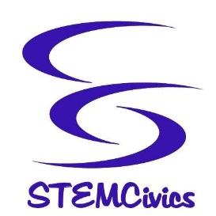 Title I – Parents’ Right-to-Know Letter

Dear Parent/Guardian:

The Every Student Succeeds Act (ESSA) was passed by the U.S. Congress and signed into law on December 10, 2015. The ESSA replaces the No Child Left Behind Act (NCLB) and is the latest reauthorization of the Elementary and Secondary Education Act (ESEA).

Although NCLB was designed to make changes in teaching and learning in order to increase students’ academic achievement, the Highly Qualified Teacher (HQT) provision under NCLB was eliminated from the ESSA. Despite this fact, all educators in New Jersey still are required to hold the appropriate state certificate/license for their given position.

Under the ESSA, all schools receiving Title I funds must inform parents of their right to ask schools about the professional qualifications of their child’s teachers and paraprofessionals. Our school receives Title I funding and we are happy to share this information with you upon request.

New Jersey has some of the most qualified teachers in the country, and we are extremely proud of the quality of the teaching staff in the STEMCivics Charter School District. All our classroom teachers have college degrees and many have advanced degrees. In addition, every teacher continues learning through professional development activities and our teachers are evaluated each year to make sure their teaching skills remain at the highest possible level.

I encourage you to support your child’s education and communicate with your child’s teacher(s) on a regular basis. For more information on ESSA, and the role of parents, please visit the United States Department of Education’s (USDE) website at http://www.ed.gov/essa.

By partnering, families and educators can provide your child with the best education possible.

