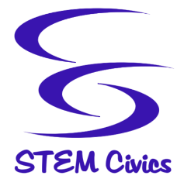
720 Bellevue Avenue
Trenton, NJ 08618
Tel: 609-664-8326
www.STEMCivics.org

Office of the Assistant Principal

2018-2019 Title I School-Parent Compact

STEMCivics at PURPLEfect Parc Middle School, and the parents of the students participating in activities, services, and programs funded by Title I, Part A of the Elementary and Secondary Education Act (ESEA) (participating children), agree that this compact outlines how the parents, the entire school staff, and the students will share the responsibility for improved student academic achievement and the means by which the school and parents will build and develop a partnership that will help children achieve the State’s high standards.

School Responsibilities:
- Provide high-quality curriculum and instruction in a supportive and effective learning environment that enables the participating children to meet the State’s student academic achievement standards.
- Hold parent-teacher conferences twice a year during which this compact will be discussed as it relates to the individual child’s achievement. Specifically, those conferences will be held on; November 28 & 29, and March 20 & 21.
- Provide parents with frequent reports on their children’s progress.
- Provide parents reasonable access to staff.
- Provide parents opportunities to volunteer and participate in their child’s class, and to observe classroom activities.

Parent Responsibilities:
We, as parents, will support our children’s learning in the following ways:
- Monitor attendance
- Making sure homework is completed
- Monitoring amount of television their children watch
- Participating, as appropriate, in decisions relating to my children’s education
- Promoting positive use of my child’s extracurricular time
- Staying informed about my child’s education and communicating with the school by promptly reading all notices from the school or the school district either received by my child or by email and responding, as appropriate

